**Project Description**

NUVHEN is designed to assist users with specific food allergies or dietary preferences. The app provides personalized meal recommendations and identifies restaurants that cater to users' dietary needs. A unique feature of the app is its scanner function, which allows users to scan product barcodes. The app then displays a list of ingredients, helping users quickly determine if a product contains any allergens or ingredients they wish to avoid.

**System Requirements**

| **Requirement** | **Minimum Requirements** | **Recommended Requirements** | **Other Requirements** |
| --- | --- | --- | --- |
| Processor Cores | Dual-core | Quad-core |  |
| OS | iOS 11 / Android 8.0 | iOS 14 / Android 10 |  |
| RAM | 2 GB | 4 GB |  |
| Permissions | Camera, Internet, Location | Camera, Internet, Location, Notifications | Camera, Internet, Location |

**Prototype Description**

The prototype for the NUVHEN app can be viewed using this [link](https://www.canva.com/design/DAGKBnNiRLM/0eG2xVE5Ix3eaEkvxVdUAg/edit). The prototype showcases the core functionalities of the app, including the meal recommendation system, restaurant locator, and product scanner.

**Problem Scenario: Sarah's Day Out with NUVHEN**

Sarah opens the NUVHEN app as she prepares for her day. The sleek login screen greets her, offering options to log in with email, Google, or Facebook. Sarah quickly enters her email and password, and with a tap, she’s logged in and ready to go. For new users, the "Sign Up" button provides a seamless way to create an account, where they can enter their email, set a password, and fill in details about their dietary preferences and allergies.

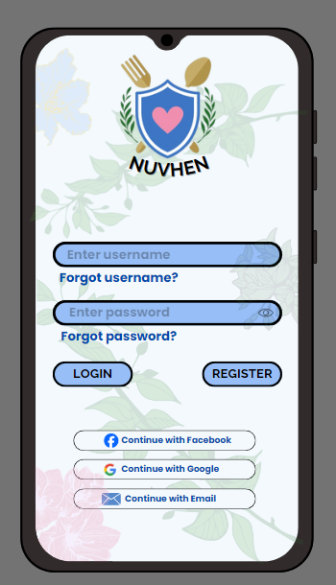

Later in the day, Sarah finds herself at the grocery store, eyeing a new snack bar. She pulls out her phone and taps the "Scanner" icon located at the bottom of the NUVHEN home screen. The app prompts her to grant camera access, and once she does, Sarah aims her camera at the snack bar’s barcode. In an instant, NUVHEN scans the product and presents a detailed list of ingredients. Sarah spots peanuts and gluten highlighted in red, confirming the snack isn’t safe for her. Grateful for the quick check, she puts the bar back on the shelf.

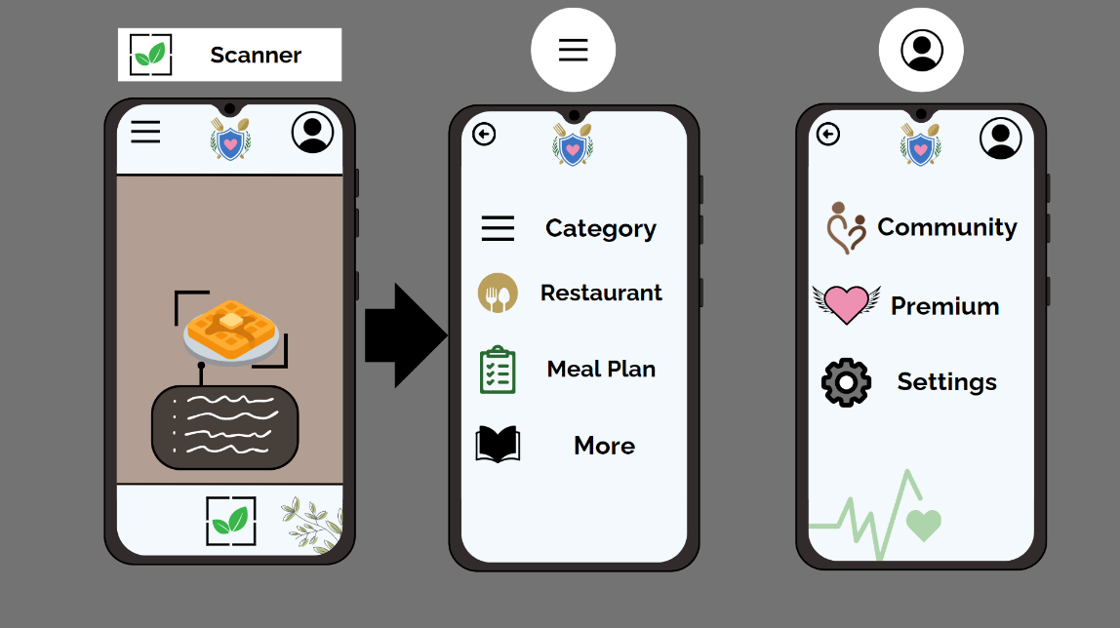

As lunchtime approaches, Sarah plans to meet her friends and wants to ensure the restaurant they choose can cater to her vegan, peanut-free, and gluten-free diet. She opens NUVHEN again and taps on the "Restaurant" icon. The app asks for her location, which she shares via GPS. NUVHEN then allows her to specify her dietary needs and allergies. Within seconds, a curated list of nearby restaurants appears, all meeting her criteria. Sarah selects “Green Delight” from the list to get more details. The app provides a detailed view, including menu highlights, user reviews, and confirmation that the restaurant offers vegan and gluten-free options. Confident in her choice, Sarah shares the restaurant details with her friends and heads out for a safe and enjoyable meal.

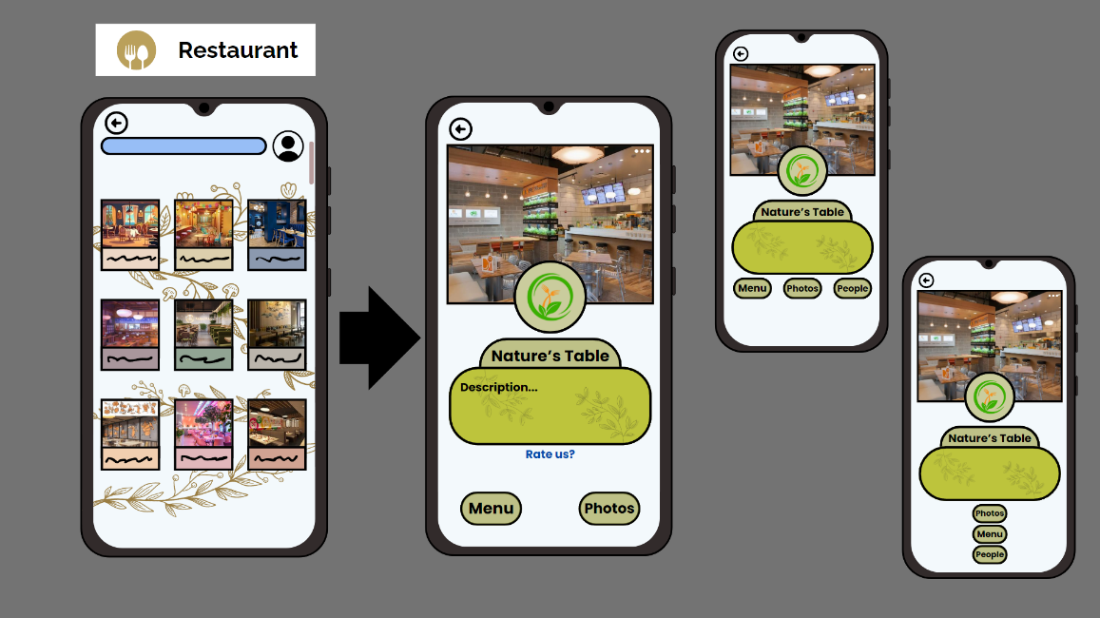

Sarah’s day is made easier and safer with NUVHEN, allowing her to navigate her dietary restrictions effortlessly whether she’s grocery shopping or dining out.

**Rationale**

The primary purpose of NUVHEN is to provide users with a reliable and user-friendly tool that helps them manage their food allergies and dietary preferences. With the increasing prevalence of food allergies and the rising interest in various dietary lifestyles, there is a growing need for an app that can offer personalized recommendations and safety checks. NUVHEN addresses this need by combining meal recommendations, restaurant locators, and a product scanner in a single app, ensuring users have comprehensive support in their daily dietary choices.

**Changes in Requirements**

Based on initial user feedback and testing, the following changes have been made to the app requirements:

1. **Enhanced Scanner Functionality:**
   * Initial Requirement: Basic ingredient list display.
   * Updated Requirement: Highlighting of allergens and integration with a broader database for more accurate results.
2. **User Interface Improvements:**
   * Initial Requirement: Simple UI.
   * Updated Requirement: More intuitive navigation and improved visual design based on user preferences.
3. **Expanded Dietary Preferences:**
   * Initial Requirement: Common allergies and dietary options.
   * Updated Requirement: Inclusion of more specialized diets (e.g., FODMAP, ketogenic) and customization options.
4. **Location-Based Services:**
   * Initial Requirement: Basic GPS functionality.
   * Updated Requirement: Enhanced location accuracy and integration with popular map services for better restaurant recommendations.

**Initial Evaluation Plan**

The initial evaluation plan for NUVHEN involves the following steps:

1. **User Testing:**
   * Recruit a diverse group of users with various allergies and dietary preferences.
   * Have users complete tasks such as logging in, scanning products, and finding restaurants.
2. **Feedback Collection:**
   * Use surveys and interviews to gather detailed feedback on user experience, functionality, and satisfaction.
   * Focus on specific areas like ease of use, accuracy of recommendations, and overall app design.
3. **Data Analysis:**
   * Analyze feedback to identify common issues and areas for improvement.
   * Measure user satisfaction levels and identify any patterns or trends in the data.
4. **Iterative Improvements:**
   * Implement changes based on user feedback and retest the app with the same or new group of users.
   * Continue the cycle of testing and improvement to refine the app.
5. **Final Evaluation:**
   * Conduct a comprehensive evaluation after iterative improvements.
   * Ensure that all identified issues have been addressed and that the app meets user needs effectively.

By following this evaluation plan, NUVHEN aims to provide a high-quality, user-friendly experience that reliably supports users in managing their dietary needs.